**Personal portfolio summary (release 2)**

I, Jianle Zheng, a team member of TNT team (#42). I take the responsibility of database design and white box testing among our seven-people team. Besides, I have done some black box testing, where I act myself as a user to get through the media vault.

In the release 2, there are five artefacts can be taken as the examples of my work as following:

1. **Database updated.doc**

The database of media vault is updated over time. This document contains several tables which compose current media vault database.

1. **Test Case-share media.xlsx**

This artifact shows the test case of media sharing process, which is created with a customer view. This document provides steps of sharing media to other people and the results of each step, which can be used by developers to check the availability of this function.

1. **Media vault- share media process.pdf**

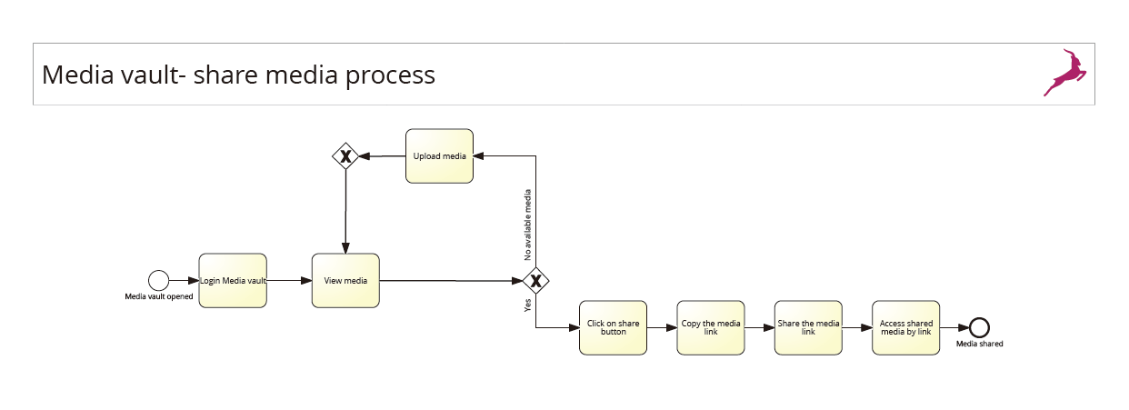

Figure 1 Share media process in BPMN

The figure 1 is a screenshot of sharing media process, which is created by BPMN. This

1. **Test Case-drop in recycle bin.xlsx**

This test case shows processes of dropping media in recycle bin, which is based on a customer view. This document provides the results by steps, which can be used by developers to check the availability of this function.

1. **FAQ document & Help Request.doc**

The contexts of FAQ and Help request pages are included into this document, which can be used for designing these two webpages.

These five items can be taken as examples of my work in release 2. However, my contributions are not limited to these. I have done my duties in peer review business letter and given some suggestions on UI design. Furthermore, all of us attended every week’s group meetings actively and formed into an effective workplace.

Jianle Zheng

TNT Team (#42)

26/10/2015